Brass or Iron single row angular contact ball bearing (QJF1028)
Structure: Angular Contact | Type: Ball | Brand Name: ZWYZ
Bore Size: 100 - 800 mm | Outside Diameter: 120 - 1200 mm | Model Number: QJF1028
Precision Rating: P0,P4,P5,P6 | Seals Type: Wooden packing | Number of Row: four point
Place of Origin: China (Mainland) | Brand name: ZWYZ | Certificates: ISO9001:2008
Standard: National standard | Material: Brass or Iron | Cage: Steel or Brass
Stock: Available | Means of transport: By sea or by air | Address: Wafangdian Liaoning China
Package: Wooden cages & According to your order... | Export area: US,UK, Philippine ,Japen...
Packaging Detail: Wooden cages as requested & 1.Colored single box package 1pcs 2.outer container.Five layers of corrugated paper cases 300*260*190mm 10pcs 3.Tray:Materical qualiy' Do not smoke to steam woddiness iron quality Project plastics 1200*950*750mm 4.Processing non-standard bearing, bearing repair is our advatage.please contact the Department of Comprehensive.
Delivery Detail: 30~40 workdays
Specifications:
angular contact ball bearing
1.Standard:ISO9001:2008
2.ID Size:100mm-800mm
3.Brand Name:ZWYZ
4.High quality ,lower price.
Angular contact ball bearing:
1.High quality and good service
2.Less friction and low noise
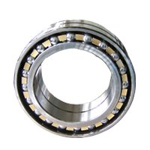 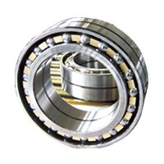
3.Competitve price
4.Durable
5.Ability to carry heavy loads
6.Less coefficient of friction
7.High limiting speed
8.Large size range:inner diameter from 100mm-800mm.
9.Variations of structure:7000C,7000AC,7000A,7000B,DB,DF,QJ,QJF...
1 Certificates: ISO9001:2008 etc.
2 Material: GCr15
3 Bore Size: 100mm-800mm or according to your order.
4 Stock: Available
5 Export Area: US,UK,Philippine,Japen…
6 Delivery Time: 30-40 days or according to your order.
7 Physical Characteristics:
1) have raceways in the inner and outer rings that are displaced with respect to each other in the direction of the bearing axis.
2) This means that they are designed to accommodate combined loads, i. E. Simultaneously acting radial and axial loads.
3) The axial load carrying capacity of increases with increasing contact angle.
4) The contact angle is defined as the angle between the line joining the points of contact of the ball and the raceways in the radial plane, along which the load is transmitted from one raceway to another, and a line perpendicular to the bearing axis.
5) features:
1: Load capacities are higher than deep groove ball bearings of same dimensions
2: Used for bearing radial-axial combined loads or pure thrust loads
6) Types:
1:Single row angular contact ball bearings
2:Double row angular contact ball bearings
3:Four-point contact ball bearings
7) Mounting
/DB: Mount in duplex, back to back
/DF: Mount in duplex, face to face
/DT: Mount in duplex, tandem
8) Internal structure:
C: Normal contact angle a=15
AC: Normal contact angle a=25
B: Normal contact angle a=40
8 Product Applications:
Angular contact ball bearing is apply for :
milling
machine shafts
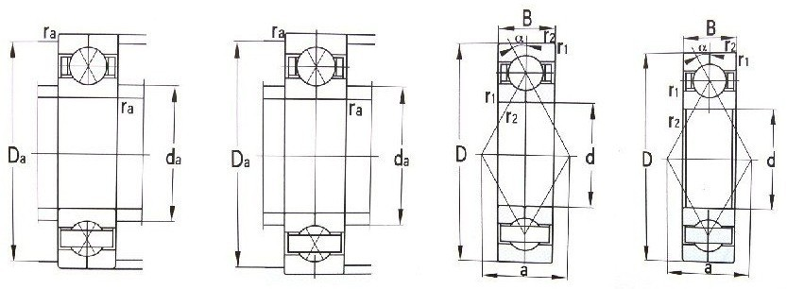
Related Keywords: Four-Point Contact Ball Bearings Brass Angular Contact Ball Bearings Double Rows Angular Contact Ball Bearing
Email: asiabearings@gmail.com
Homepage: http://www.asiabearings.com

