SKF NUP210 Chrome steel cylindrical roller bearing

1 | Brand | SKF 100% Origin
2 | Model Number | NUP210ECM
3 | Detail: | 50*90*20
4 | Place of Place of Origin | Germany
5 | Description | Cylindrical roller bearings belong to separable bearings, with easy method of mounting and dismounting. They can be classified into single row, double rows and four rows. As per different rib of the ring, single-row cylindrical roller bearings can be divided into N series, NU series, NF series, NUP series and so on. Cylindrical roller bearings carry a very heavy radial loads.
6 | Material | GCr15
7 | Closures | Unsealed/Sealed
8 | Structure | Cylindrical roller bearings N series
8 | Structure | Cylindrical roller bearings NU series
8 | Structure | Cylindrical roller bearings NF series
8 | Structure | Cylindrical roller bearings NUP series
9 | Features: | heavy radial load,heavy shock load, high rotation speed
10 | Application | These bearings are mostly found in middle-sized and large-sized motors, electricity generators, internal combustion engines, gas turbines, machine tool spindles, deceleration devices, unloading and lifting machines and other industrial machines.
11 | Payment Terms | T/T or L/C at sight
12 | Delivery time | Within 3-20 days against your deposit
13 | Brand Name | FAG, HRB, IKO, INA, KOYO, NACHI, NSK, NTN, SKF, TIMKEN etc.
14 | Precision Rating | P0,P2,P4,P6
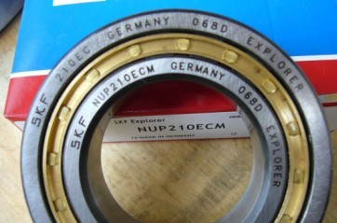
SKF NUP210 cylindrical roller bearing
Cylindrical roller bearing is widely used in metallurgy, rolling mills, mining, paper making and cement industry, etc
More models for NUP designs:
NUP2204, NUP2204E, NUP2205, NUP2205E, NUP2206, NUP2206E, NUP2207, NUP2207E, NUP2208, NUP2208E, NUP2209, NUP2209E, NUP2210, NUP2210E, NUP2211, NUP2211E, NUP2212, NUP2212E, NUP2213, NUP2213E, NUP2214, NUP2214E, NUP2215, NUP2215E, NUP2216, NUP2216E, NUP2217, NUP2217E and so on.
Related Keywords: Cylindrical Roller Bearings SKF Bearings Chrome Steel Bearing
Thanks for your attention and interest!
Please contact us with your model No or your detailed specifications or drawings and samples.
Janet Shi
Address:Room2111, Jinma Building ,NO.638 Xingyuan North Road Wuxi , Jiangsu , China
Email: guangyuejanet@yahoo.cn ；asiabearings@gmail.com
MSN: janetlove_2008@live.cn
Homepage: www.asiabearings.com

