ZAAZ 7340AC Angular Contact Ball Bearing (GCr9,GCr15,GCr15SiMn)
Structure: Angular Contact | Type: Ball | Brand Name: ZAAZ
Bore Size: 200 mm | Outside Diameter: 420 mm | Model Number: 7340AC
Precision Rating: P0,P2,P4,P5,P6,P6X | Seals Type: RS,2RS,R2,2R2.Z.2Z | Number of Row: Single Row
Place of Origin: China (Mainland) | product name: angular contact ball bearing | model: 7340AC
material: GCr9,GCr15,GCr15SiMn | width: 80mm | weight: 53kg
basic load rating: cr:cor449~655kn | limit speed rating: grease:oil 1100~1600r/min | vibration: ZIVI,Z2V2,Z3V3
rmin: 2.1 | clearance: C0,C2,C3,C5etc
Packaging Detail: wooden case,carton case or according to the customer requirements
Delivery Detail: 10--15--45days
Specifications:
angular contact ball bearing
material:GCr9,GCr15,GCr15SiMn
high revolutions
high accuracy
low noise,small vibration
angular contact ball bearing

simple introduction:

angular contact ball bearing can be subjected to both radial and axial load,it also can be subjected to pure axial load.Its axial load capacity depends on the contact angular and increases accordingly.It can be used for high speed and high precision equipments due to its high limit speed and pre-adjustable rigidity.
single-row angular contact ball bearing only can be subjected to the single directional load.so normally this kind of bearings are mounted by pair.
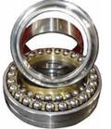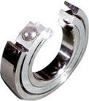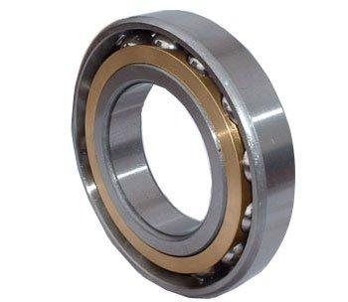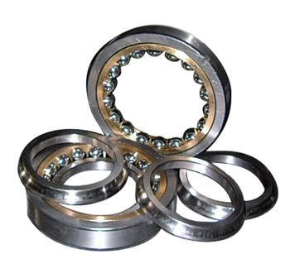
production specification sheet

product name | angular contact ball bearing
brand | zaaz
model | 7340AC
material | GCr9,GCr15,GCr15SiMn
inner size | 200mm
outer size | 420mm
width | 80mm
weight | 53kg
basic load rating | cr:cor 449~665kn
limit speed rating | grease:oil 1100~1600r/min
precision grade | P0,P2,P4,P5,P6,P6X
seal type | RS,2RS,R2,2R2.Z.2Z
rmin | 2.1
vibration | z1v1,z2v2,z3v3
clearance | C0,c2,c3,c5etc
quality system | ISO9001:2008
feature:
1.high revolutions
2.high accuracy
3.low noise,small vibration
4.it can be subjected by axial load and radial load
5.used by pair
application:precision instrument
Related Keywords: Chrome Steel Angular Contact Ball Bearings Double Rows Angular Contact Ball Bearing Single Row Angular Contact Ball Bearing
Email: asiabearings@gmail.com
Web: http://www.asiabearings.com/

