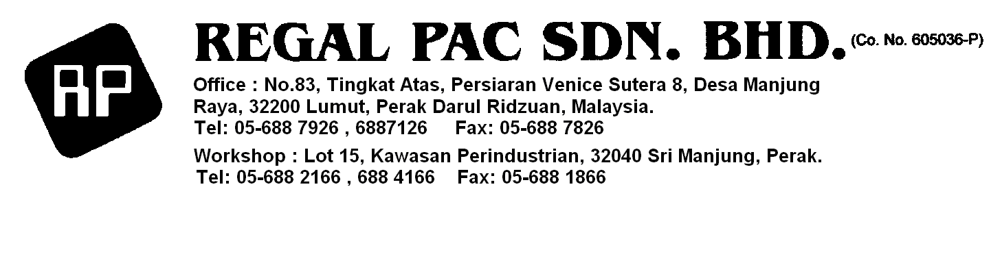

Dear Sir / Madam.

Kindly quote for the attached list of bearings and indicate your delivery period.

- Ball Bearing 16014 DKFD A0 – 1 in no.
- Ball Bearing 6206 DKFD 21 -- 1 in no.
- Roller Bearing 220R HIC Japan (NJ2210 RC 525 – 1 in no.
- Roller Bearing 2208 BC 6 NJ – 1 in no.

Thanking you in anticipation.

Suppiah Ghandi
Senior Project Coordinator
Regal Pac Sdn Bhd,
Lot 15 Kawasan Perindustrian Seri Manjung,
32040 Seri Manjung
Perak.

Tel : 05 6882166 / 05 688 4166

Fax : 05 688 1866

Email : kaysg_rpac@yahoo.com

Webpage : www.regalpac.com

Page 1 of 2

